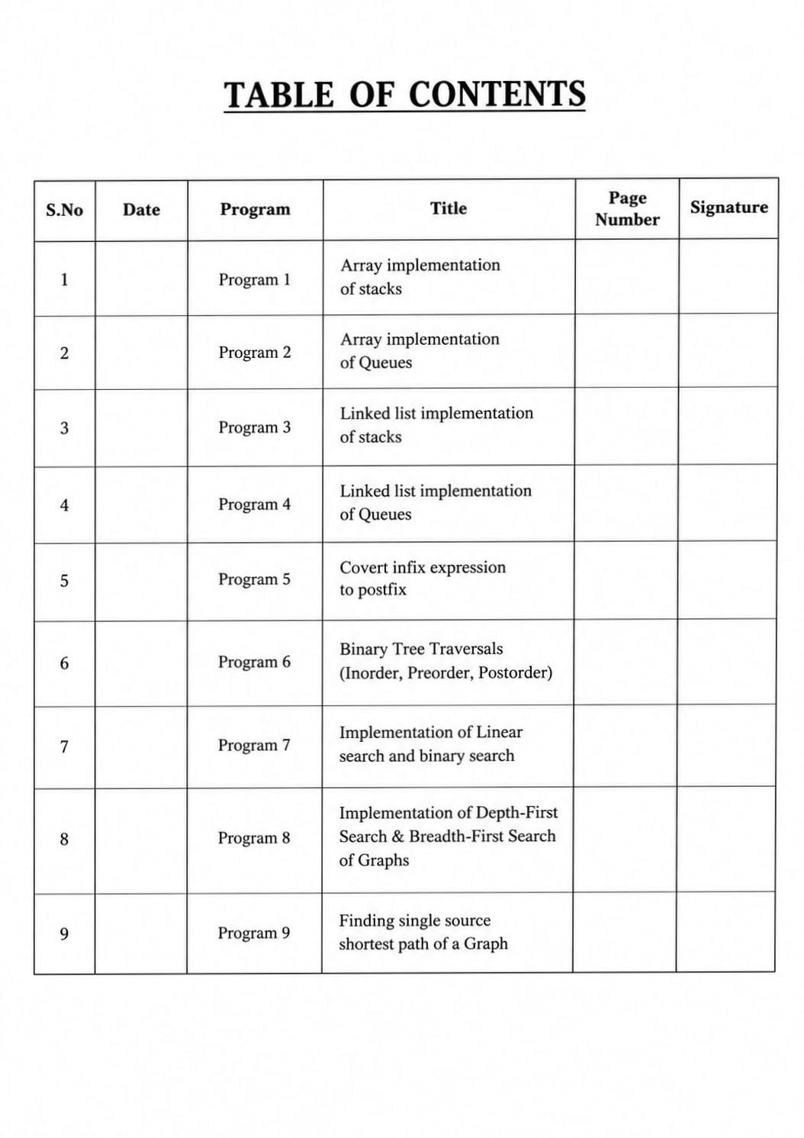

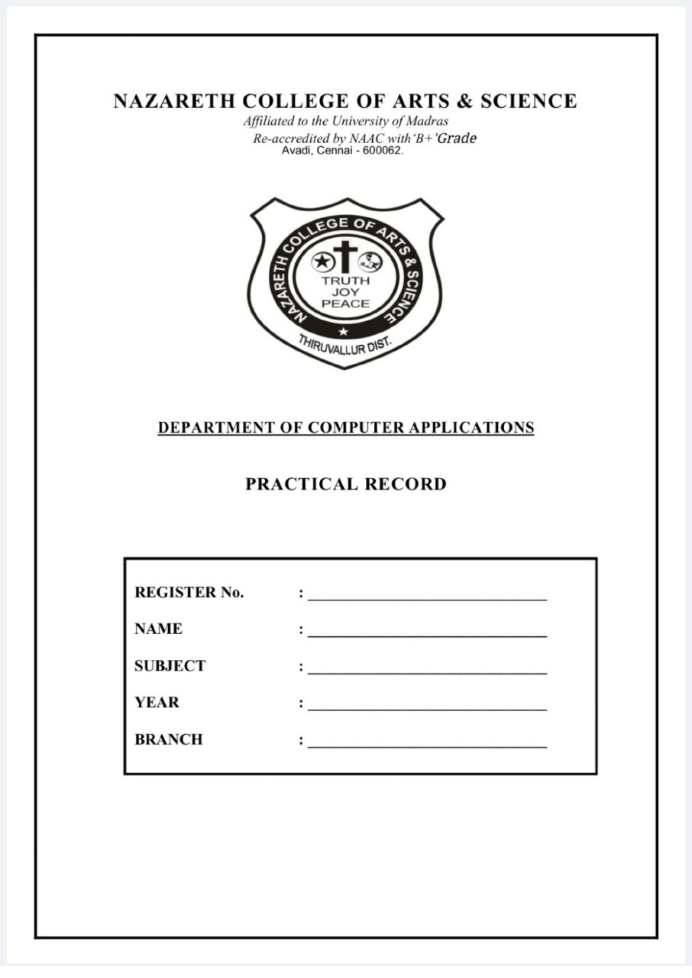
- Array implementation of stacks
#include <iostream>

Using namespace std;

#define MAX 3

Class Stack

{

Private:

Int stack[MAX];

Int top;

Public:

// Constructor

Stack()

{

Top = -1;

}

// Push operation

Void push(int value)

{

If (top == MAX – 1)

{

Cout << “Stack overflow” << endl;

}

Else

{

Top++;

Stack[top] = value;

Cout << value << “ pushed into stack” << endl;

}

}

// Pop operation

Void pop()

{

If (top == -1)

{

Cout << “Stack underflow” << endl;

}

Else

{

Cout << stack[top] << “ popped from stack” << endl;

Top--;

}

}

// Display operation

Void display()

{

If (top == -1)

{

Cout << “Stack is empty” << endl;

}

Else

{

Cout << “Stack elements are:” << endl;

For (int I = top; I >= 0; i--)

{

Cout << stack[i] << endl;

}

}

}

};

Int main()

{

Stack s;

s.push(10);

s.push(20);

s.push(30);

s.display();

s.pop();

s.display();

return 0;

}

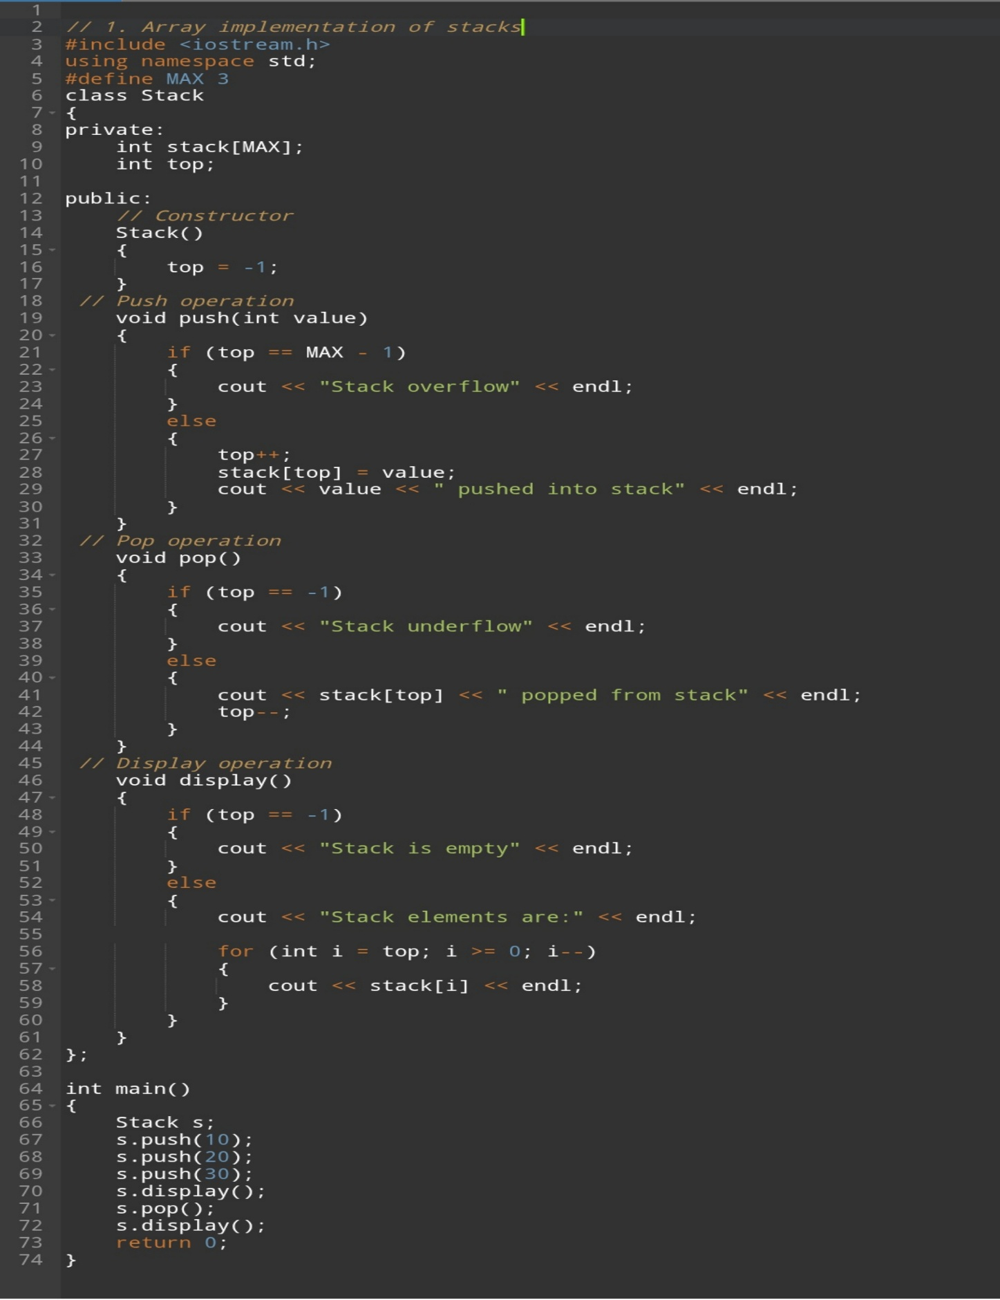
Program screenshot
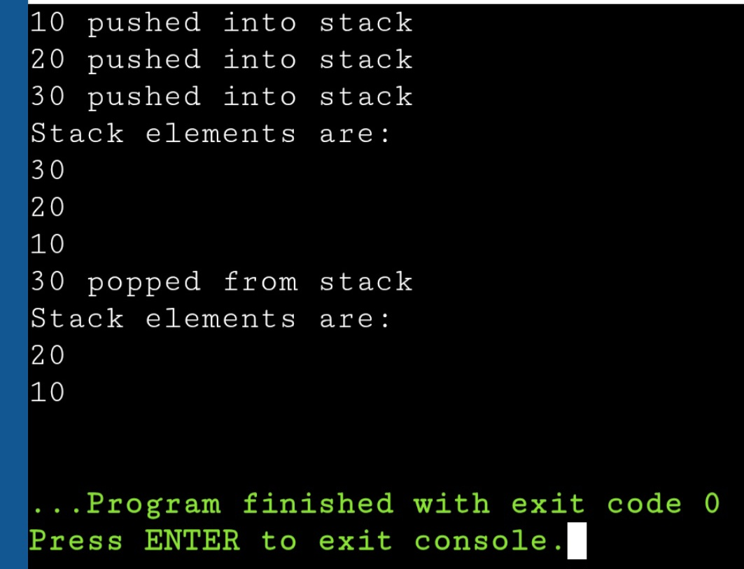
Output screenshot

- Array implementation of Queues
#include <iostream>

Using namespace std;

#define MAX 5

Class Queue

{

Private:

Int queue[MAX];

Int front, rear;

Public:

Queue()

{

Front = -1;

Rear = -1;

}

// Enqueue operation

Void enqueue(int value)

{

If (rear == MAX – 1)

{

Cout << “Queue Overflow” << endl;

}

Else

{

If (front == -1)

Front = 0;

Rear++;

Queue[rear] = value;

Cout << value << “ inserted into queue” << endl;

}

}

// Dequeue operation

Void dequeue()

{

If (front == -1 || front > rear)

{

Cout << “Queue Underflow” << endl;

}

Else

{

Cout << queue[front] << “ deleted from queue” << endl;

Front++;

If (front > rear)

{

Front = -1;

Rear = -1;

}

}

}

// Display operation

Void display()

{

If (front == -1)

{

Cout << “Queue is empty” << endl;

}

Else

{

Cout << “Queue elements are: “;

For (int I = front; I <= rear; i++)

{

Cout << queue[i] << “ “;

}

Cout << endl;

}

}

};

Int main()

{

Queue q;

q.enqueue(10);

q.enqueue(20);

q.enqueue(30);

q.display();

q.dequeue();

q.display();

return 0;

}

